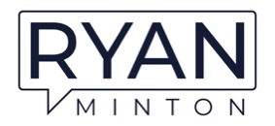

Ryan Minton Bio – For Print
With over 20 years of experience leading world-class hospitality brands, Ryan Minton is a Best Selling Author, Keynote Speaker and an influential voice in creating exceptional customer and employee experiences. As a senior executive representing hospitality giants like Hilton, Marriott, and IHG, Ryan has a proven track record of driving record revenues, profits, and engagement through his keen eye for operational excellence and talent for fostering dynamic teams.
Regarded as a top speaker and social media influencer in customer and employee experience, Ryan brings a unique blend of strategic vision and on-the-ground leadership. He has been internationally recognized as one of the World's Best Speakers in two separate categories - Hospitality and Customer Experience - by Global Gurus for his ability to inspire audiences through storytelling and actionable insights. Ryan also sits on the Forbes Business Council and holds an expert panel position with Newsweek.

